Please find below an example of the CreationCommand class implemented for the Webpage task.

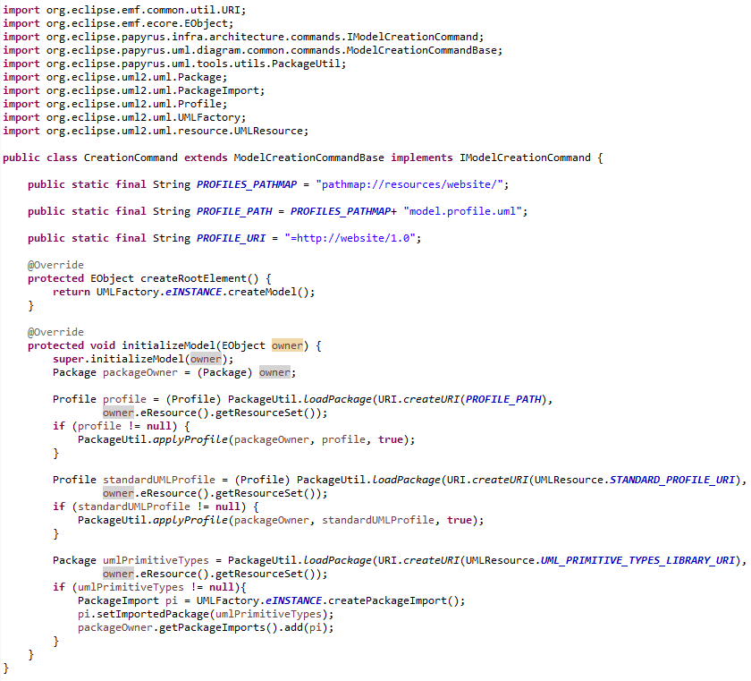

**Note: You will need to synchronise the *pathmap* definition within your UML editor plug-in, which will appear in task 7.**